 | 10.1.8 Editors - Compositor Editor - Header - Add Menu - Color
Table of content
Detailed Table of Content 1
Add menu - Color 8
Adjust – Sub Menu 8
Alpha Convert 19
Alpha Over 19
Set Alpha 20
Combine Color 21
Separate Color 22
Depth Combine 24
Mix Color 24
Blackbody 25
ColorRamp 26
Convert Colorspace 27
Convert to Display 28
Invert Color 29
RGB to BW 30

Detailed Table of Content

Detailed table of content
Detailed Table of Content 1
Add menu - Color 8
Adjust – Sub Menu 8
Brightness/Contrast 8
Inputs 8
Image 8
Brightness 8
Contrast 8
Outputs 8
Color 8
Color Balance 9
Inputs 9
Factor 9
Image 9
Properties 9
Type 9
Lift/Gamma/Gain 9
Lift 9
Gamma 9
Gain 9
Color wheel 9
Offset/Power/Slope (ASC-CDL) 9
Offset 9
Basis 9
Power 9
Slope 10
Color wheel 10
White Point 10
Input 10
Temperature 10
Tint 10
Picker 10
Output 10
Temperature 10
Tint 10
Picker 10
Outputs 10
Image 10
Advanced 10
The Offset/Power/Slope Formula 10
Color Correction 11
Input 11
Image 11
Mask 11
Properties 11
Master panel 11
Saturation 11
Contrast 11
Gamma 11
Gain 11
Offset 11
Highlights panel 11
Saturation 11
Contrast 11
Gamma 12
Gain 12
Offset 12
Midtones panel 12
Saturation 12
Contrast 12
Gamma 12
Gain 12
Offset 12
Midtones panel 12
Saturation 12
Contrast 12
Gamma 12
Gain 12
Offset 12
Shadows panel 12
Saturation 12
Contrast 13
Gamma 13
Gain 13
Offset 13
Tonal range 13
Mid tones Start, Mid tones End 13
Channels 13
Red, Green, Blue 13
Outputs 13
Color 13
Exposure 13
Inputs 13
Image 13
Exposure 13
Outputs 13
Image 13
Gamma 14
Inputs 14
Image 14
Gamma 14
Outputs 14
Image 14
Hue Correct 14
Inputs 14
Image 14
Factor 14
Properties 14
Level 14
Tools menu 14
Reset View 14
Reset Curve 14
Auto Handle 14
Vector Handle 15
Auto Clamped 15
X / Y 15
Delete Points 15
Output 15
Hue/Saturation/Value 15
Inputs / Properties 15
Image 15
Hue 15
Saturation 15
Value 15
Factor 15
Image 15
Outputs 16
Image 16
Hue/Saturation Tips 16
RGB Curves 16
Inputs 16
Image 16
Factor 16
Black Level 16
White level 16
Properties 16
Tone 16
Curve Field 17
Channel buttons 17
Navigation elements 17
Zoom in and out 17
Clipping 17
Tools 17
Reset View 17
Extend horizontal 17
Extend extrapolated 17
Reset Curve 17
Curve edit field 17
Selecting Points 17
Adding Points 17
Curve point settings 18
Vector Handle 18
Auto Handle 18
Auto Clamped Handle 18
Outputs 18
Color 18
Tonemap 18
Inputs 18
Image 18
Properties 18
Type 18
Rh Simple 18
Key 18
Balance 18
Gamma 18
R/D Photo receptor 19
Intensity 19
Contrast 19
Adaptation 19
Color Correction 19
Outputs 19
Image 19
Alpha Convert 19
Input 19
Image 19
Properties 19
Mapping Type 19
Output 19
Image 19
Alpha Over 19
Inputs 20
Background 20
Foreground 20
Factor 20
Straight Alpha 20
Properties 20
Over 20
Disjoint Over 20
Conjoint Over 20
Outputs 20
Image 20
Set Alpha 20
Inputs 20
Image 20
Alpha 21
Type 21
Apply Mask 21
Replace Alpha 21
Outputs 21
Image 21
Combine Color 21
Input 21
Mode 21
Input – RGB mode 21
R, G, B and A 21
Input – HSV mode 22
H , S and V 22
Input – HSL mode 22
H , S and L 22
Input – YCbCRA mode 22
Y, Cb, Cr and A 22
Properties 22
Modes 22
Input – YUVA mode 22
Y, U, V and A 22
Output 22
Image 22
Separate Color 22
Input 22
Mode 22
Output – RGB mode 23
R, G, B and A 23
Output – HSV mode 23
H , S and V 23
Output – HSL mode 23
H , S and L 23
Output – YCbCRA mode 23
Y, Cb, Cr and A 23
Properties 23
Modes 23
Output – YUVA mode 23
Y, U, V and A 23
Depth Combine 24
Inputs 24
A 24
Depth A 24
B 24
Depth B 24
Use Alpha 24
Anti-Alias Z 24
Outputs 24
Result 24
Depth 24
Mix Color 24
Inputs 25
Factor 25
Image 1 25
Image 2 25
Properties 25
Mix 25
Clamp 25
Outputs 25
Image 25
Blackbody 25
Inputs 25
Temperature 25
Outputs 25
Color 25
ColorRamp 26
Inputs 26
Factor 26
Properties 26
Color Ramp 26
Controls 26
+ 26
- 26
Tools menu 26
Flip Color Ramp 26
Distribute Stops from Left 26
Distribute Stops Evenly 26
Eyedropper (pipette icon) E 26
Reset Color Ramp 26
Color Mode 26
RGB 26
HSV/HSL 26
Interpolation 27
Ease 27
Cardinal 27
Linear 27
B-Spline 27
Constant 27
Color Ramp 27
Active Color Stop elements 27
Choose active color stop 27
Pos 27
Outputs 27
Color 27
Alpha 27
Convert Colorspace 27
Input 28
Image 28
Properties 28
From 28
To 28
Output 28
Image 28
Convert to Display 28
Inputs 28
Image 28
Invert 28
Properties 29
Display 29
View 29
Look 29
Output 29
Image 29
Invert Color 29
Inputs 29
Color 29
Factor 30
Invert Color 30
Invert Alpha 30
Outputs 30
Color 30
RGB to BW 30
Inputs 30
Image 30
Outputs 30
Val 30

Add menu - Color
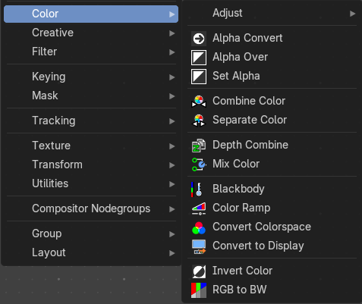
Here you find color related nodes.

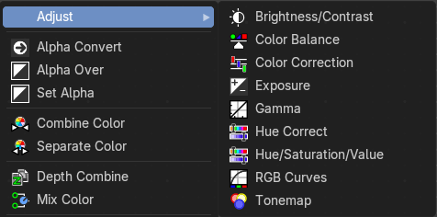
Adjust – Sub Menu
The Adjust sub menu where you can find nodes that adjust color.

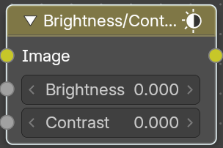
Brightness/Contrast
Adjust the brightness and contrast.

Inputs

Image
The image input

Brightness
An additive-type factor by which to increase the overall brightness of the image. Use a negative number to darken an image.

Contrast
A scaling type factor by which to make brighter pixels brighter, but keeping the darker pixels dark. Higher values make details stand out. Use a negative number to decrease the overall contrast in the image.

Outputs

Color
Standard output.
Note: It is possible that this node will put out a value set that has values beyond the normal range, i.e. values greater than one and less than zero. If you will be using the output to mix with other images in the normal range, you should clamp the values using the Map Value node (with the Min and Max enabled), or put through a Color Ramp node (with all normal defaults).

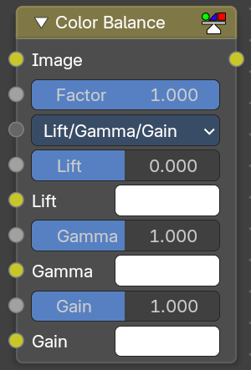
Color Balance
The Color Balance node can adjust the color and values of an image.

Inputs

Factor
Controls the amount of influence the node exerts on the output image.

Image
Standard image input.

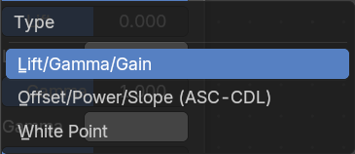
Properties

Type
You can choose between different formulas.

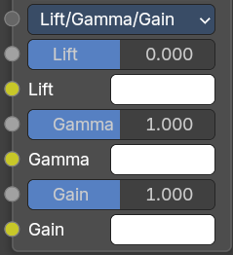
Lift/Gamma/Gain

Lift
Increases the value of dark colors.

Gamma
Will adjust mid tones.

Gain
Adjusts highlights.

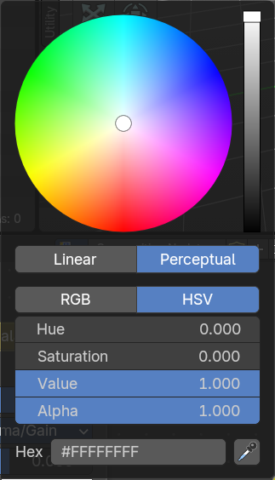
Color wheel
When you click at one of the colors then you will call a color wheel where you can adjust the colors.

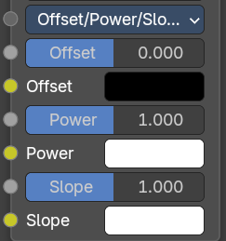
Offset/Power/Slope (ASC-CDL)

Offset
Summand. (Adjusts the overall brightness.)

Basis
Additional offset, allows to specify a negative Offset value.

Power
Over-all exponent. (Adjusts the mid tones.

Slope
Multiplier. (Adjusts the highlights.)

Color wheel
When you click at one of the colors then you will call a color wheel where you can adjust the colors.

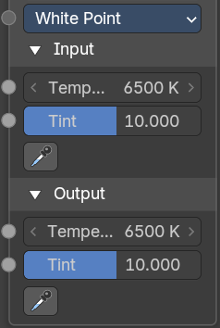
White Point
Chromatic adaption from a different white point.

Input

Temperature
Color temperature of the inputs white point.

Tint
Color tint of the inputs white point.

Picker
Pick an input whitepoint. The color that gets mapped to white.

Output

Temperature
Color temperature of the outputs white point.

Tint
Color tint of the outputs white point.

Picker
Pick an output whitepoint. The color which gets white gets mapped to.

Outputs

Image
The output image.

Advanced

The Offset/Power/Slope Formula
out = (i × s + o)p
where:
out: The color graded pixel code value.
i: The input pixel code value (0 to 1) (black to white).
s: Slope (any number 0 or greater, nominal value is 1.0).
o: Offset (any number, the nominal value is 0).
p: Power (any number greater than 0, nominal value is 1.0).

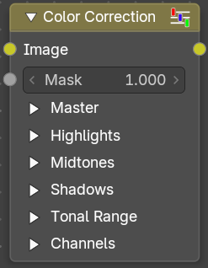
Color Correction
With the Color Correction node you can adjust the color of an image. Separated in several tonal ranges (highlights, mid tones and shadows) and only affect the necessary RGB channels.

Input

Image
Image Input.

Mask
Input a mask to cover parts of the image so that they are affected.

Properties

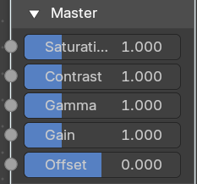
Master panel

Saturation
Adjusts the image’s saturation.

Contrast
Adjust image contrast.

Gamma
Exponential gamma correction, affecting the whole image. (Works like Power in the Color Balance node.)

Gain
Multiplier, stronger influence on the whole image. (Works like Slope in the Color Balance node.)

Offset
Controls the offset of the entire image.

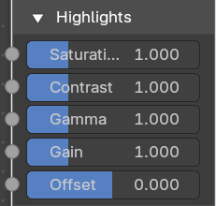
Highlights panel

Saturation
Adjusts the saturation of the highlights.

Contrast
Adjust image contrast of the highlights.

Gamma
Exponential gamma correction, affecting the highlights of the image. (Works like Power in the Color Balance node.)

Gain
Multiplier, stronger influence on the highlights. (Works like Slope in the Color Balance node.)

Offset
Controls the offset of the of the highlights.

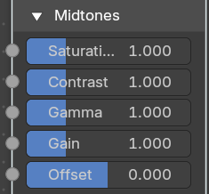
Midtones panel

Saturation
Adjusts the saturation of the midtones.

Contrast
Adjust image contrast of the midtones.

Gamma
Exponential gamma correction, affecting the midtones of the image. (Works like Power in the Color Balance node.)

Gain
Multiplier, stronger influence on the midtones. (Works like Slope in the Color Balance node.)

Offset
Controls the offset of the of the midtones.

Midtones panel

Saturation
Adjusts the saturation of the midtones.

Contrast
Adjust image contrast of the midtones.

Gamma
Exponential gamma correction, affecting the midtones of the image. (Works like Power in the Color Balance node.)

Gain
Multiplier, stronger influence on the midtones. (Works like Slope in the Color Balance node.)

Offset
Controls the offset of the of the midtones.

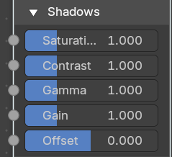
Shadows panel

Saturation
Adjusts the saturation of the shadows.

Contrast
Adjust image contrast of the shadows.

Gamma
Exponential gamma correction, affecting the shadows of the image. (Works like Power in the Color Balance node.)

Gain
Multiplier, stronger influence on the shadows. (Works like Slope in the Color Balance node.)

Offset
Controls the offset of the of the shadows.

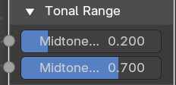
Tonal range

Mid tones Start, Mid tones End
Defines the start and the end of mid tones range, i.e. values where the whole tonal range is divided into the highlights, mid tones and shadows (there is also a smooth transition between the ranges of width 0.2 units).

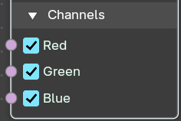
Channels

Red, Green, Blue
Specifies which RGB channels will be affected by correction.

Outputs

Color
The image output.

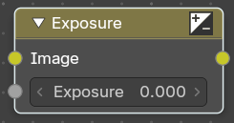
Exposure
The Exposure Node node allows you to make areas of an image brighter or dimmer.

Inputs

Image
Standard image input.

Exposure
The scalar factor to adjust the exposure of the image.

Outputs

Image
Standard image output.

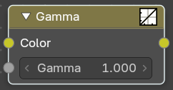
Gamma
Use this node to apply a gamma correction.

Inputs

Image
Image input.

Gamma
An exponential brightness factor.

Outputs

Image
Image output.

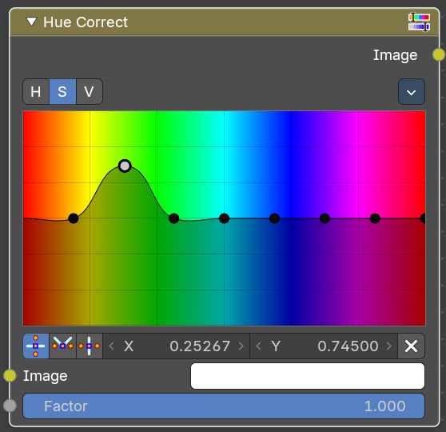
Hue Correct
With the Hue Correct Node you can adjust the Hue, Saturation, and Value of an image with an input curve.

Inputs

Image
Standard image input.

Factor
Controls the amount of influence the node exerts on the output image.

Properties

Level
H (Hue), S (Saturation), V (Value). Choose which curve you want to modify.

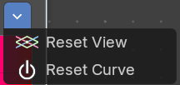
Tools menu

Reset View
Resets the view. This menu item is here dysfunctional, you cannot view in or out.

Reset Curve
Resets the curve to defaults.

Auto Handle
Sets the handle for the curve points to Auto Handle.

Vector Handle
Sets the handle for the curve points to Vector Handle.

Auto Clamped
Sets the handle for the curve points to Auto Clamped.

X / Y
The x and y position of the currently selected curve point.

Delete Points
Deletes the currently selected curve point.

Output
Image

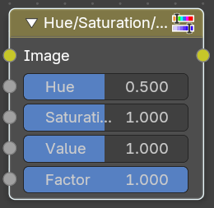
Hue/Saturation/Value
The Hue Saturation Node applies a color transformation in the HSV color space. Called “Hue Saturation Value” in shader and texture context.

Inputs / Properties
The inputs also works as properties when nothing is connected.

Image
Plug in an image.

Hue
Specifies the hue rotation of the image. 360° are mapped to (0 to 1). The hue shifts of 0 (-180°) and 1 (+180°) have the same result.

Saturation
A saturation of 0 removes hues from the image, resulting in a gray scale image. A shift greater than 1.0 increases saturation.

Value
Value is the overall brightness of the image. De/Increasing values shift an image darker/lighter.

Factor
Controls the amount of influence the node exerts on the output image.

Image
Standard input.

Outputs

Image
Standard output.

Hue/Saturation Tips
Some things to keep in mind that might help you use this node better:
Hues are vice versa
A blue image, with a Hue setting at either end of the spectrum (0 or 1), is output as yellow (recall that white, minus blue, equals yellow). A yellow image, with a Hue setting at 0 or 1, is blue.
Hue and Saturation work together.
So, a Hue of 0.5 keeps the blues the same shade of blue, but Saturation can deepen or lighten the intensity of that color.
Gray & White are neutral hues
A gray image, where the RGB values are equal, has no hue. Therefore, this node can only affect it with Value. This applies to all shades of gray, from black to white; wherever the values are equal.
Changing the effect over time
The Hue and Saturation values can be animated with a Time Node or by animating the property.

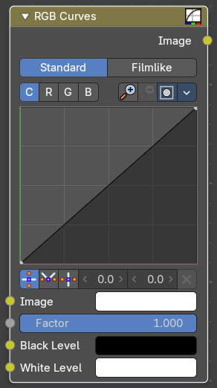
RGB Curves
The RGB Curves Node allows color corrections for each color channel and levels adjustments in the compositing context.

Inputs

Image
Standard image input.

Factor
Controls the amount of influence the node exerts on the output image.

Black Level
Defines the input color that is (linear) mapped to black.

White level
Defines the input color that is (linear) mapped to white.

Properties

Tone
What tone mapping to use. Standard or Film like.

Curve Field

Channel buttons
Clicking on one of the channels displays the curve for each.
C (Combined RGB), R (Red), G (Green), B (Blue).

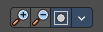
Navigation elements
They are described from left to right.

Zoom in and out
The two buttons with the magnifying glass at it zooms in and out in the curve window.

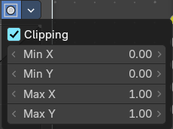
Clipping
Clipping options. Set up clipping for the stroke.

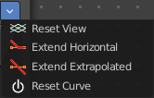
Tools
Tools is a menu where you can find some curve related tools.

Reset View
Resets the curve windows zoom.

Extend horizontal
Extends the curve before the first curve point and behind the last curve point horizontally.

Extend extrapolated
Extends the curve before the first curve point and behind the last curve point extrapolated.

Reset Curve
Resets the curve to the initial shape.

Curve edit field
Create and tweak a Bezier curve that varies the input levels (X axis) to produce an output level (Y axis).

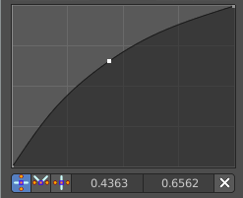
Selecting Points
You can select curve points. This reveals two edit boxes for the x and y coordinate of this point.
Selected points can be moved around. Left click at them, hold the mouse button down and move them to a new location.

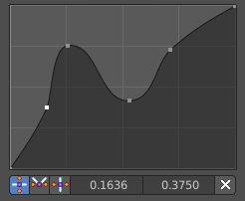
Adding Points
You can add new curve points by simply left clicking at the curve. Move the mouse to position them where you need it.

Curve point settings
When you have a point selected then you will reveal further settings at the bottom.

Vector Handle
Set handle type to Vector.

Auto Handle
Set handle type to Auto.

Auto Clamped Handle
Set handle type to Auto Clamped.

Outputs

Color
Standard output.

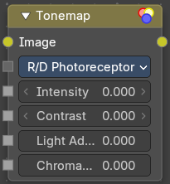
Tonemap
Tone mapping is a technique used in image processing and computer graphics to map one set of colors to another in order to approximate the appearance of high dynamic range images in a medium that has a more limited dynamic range.
Tone mapping addresses the problem of strong contrast reduction from the scene values (radiance) to the displayable range, while preserving the image details and color appearance. This is important to appreciate the original scene content.

Inputs

Image
Plug in the HDR image.

Properties

Type
There are two methods of tone mapping. Rh Simple and R/D Photo receptor.

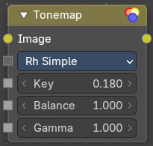
Rh Simple

Key
The value the average luminance is mapped to.

Balance
Normally always 1, but can be used as an extra control to alter the brightness curve.

Gamma
If not used, set to 1.

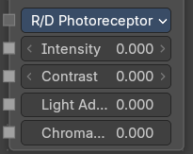
R/D Photo receptor

Intensity
A value smaller than zero darkens image. A value greater than zero makes it brighter.

Contrast
Set to 0 to use estimate from input image.

Adaptation
If 0, global; if 1, based on pixel intensity.

Color Correction
If 0, same for all channels; if 1, each independent.

Outputs

Image
The Image output.

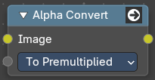
Alpha Convert
This node converts the alpha channel interpretation of an image from pre-multiplied to straight or vice versa. With a straight alpha channel you might run into artifacts at the borders when the pixels in the semi transparent areas.

Input

Image
The input image.

Properties

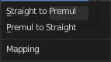
Mapping Type
Convert straight to premultiplied. Or convert premultiplied to straight.

Output

Image
The image output.

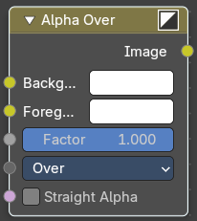
Alpha Over
The Alpha Over node is used to layer images with an alpha channel on top of one another.
Where the foreground image pixels have an alpha greater than 0, the background image will be overlaid.

Inputs

Background
Input for the background image.

Foreground
Input for the foreground image.

Factor
Controls the amount of foreground image. A factor less than 1 will make the foreground more transparent.

Straight Alpha
Defines wether teh foreground ins in straight alpha form, which is necessary to konw for proper alpha composing. Images in the compositor are in premultiplied alpha form by default. So it should be false in most cases. But if, and only if, the foreground was converted to straight alpha form for some reason, this should be set to true.

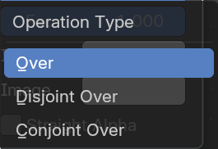
Properties

Over
The foreground goes over the background according to the alpha of the foreground.

Disjoint Over
The foreground goes over the background according to the alpha of the foreground while assuming the background is being held out by the foreground.

Conjoint Over
The foreground goes over the background according to the alpha of the foreground. But the foreground completely covers the background if it is more opaque but not necessarily completely opaque.

Outputs

Image
Image output.

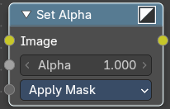
Set Alpha
The Set Alpha Node adds an alpha channel to an image.

Inputs

Image
Standard image input.

Alpha
The amount of Alpha can be set for the whole image by using the input field or per pixel by connecting to the socket.

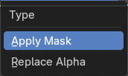
Type

Apply Mask
Multiply the alpha channel of the input image by the alpha input value.

Replace Alpha
Replace the alpha channel of the input image by the alpha input value.

Outputs

Image
The image output.

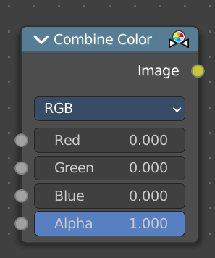
Combine Color
Combine single RGBA floating point channels into a single image.

Input

Mode
- RGB colour processing
- HSV colour processing
- HSL colour processing
- YcbCr converts an YCbCrA image to RGBA color space and unions the channels.
  - Y: Luminance, 0=black, 1=white
  - Cb: Chrominance Blue, 0=Blue, 1=Yellow
  - Cr: Chrominance Red, 0=Red, 1=Yellow
- YUV converts an YUVA image to RGBA color space. Note that U and V values range
from -0.5 to +0.5.

Input – RGB mode

R, G, B and A
The red, green, blue and alpha channels of an image.

Input – HSV mode

H , S and V
The Hue, Saturation and Value channels of an image.

Input – HSL mode

H , S and L
The Hue, Saturation and Luminescence channels of an image.

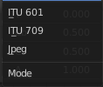
Input – YCbCRA mode

Y, Cb, Cr and A
Luminance, Chrominance Blue, Chrominance Red and Alpha input.

Properties

Modes
ITU 601, ITU 709, Jpeg. These are encoding standards for the YCbCrA color space.

Input – YUVA mode

Y, U, V and A
Luminance, Chrominance U, Chrominance V and Alpha channel.

Output

Image
The output image.

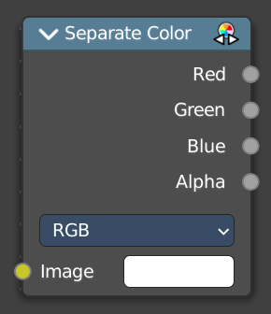
Separate Color
Separates the single RGBA channels from a single image.

Input

Mode
- RGB colour processing
- HSV colour processing
- HSL colour processing
- YcbCr converts an YCbCrA image to RGBA color space and unions the channels.
  - Y: Luminance, 0=black, 1=white
  - Cb: Chrominance Blue, 0=Blue, 1=Yellow
  - Cr: Chrominance Red, 0=Red, 1=Yellow
- YUV converts an YUVA image to RGBA color space. Note that U and V values range
from -0.5 to +0.5.

Output – RGB mode

R, G, B and A
The red, green, blue and alpha channels of an image.

Output – HSV mode

H , S and V
The Hue, Saturation and Value channels of an image.

Output – HSL mode

H , S and L
The Hue, Saturation and Luminescence channels of an image.

Output – YCbCRA mode

Y, Cb, Cr and A
Luminance, Chrominance Blue, Chrominance Red and Alpha input.

Properties

Modes
ITU 601, ITU 709, Jpeg. These are encoding standards for the YCbCrA color space.

Output – YUVA mode

Y, U, V and A
Luminance, Chrominance U, Chrominance V and Alpha channel.

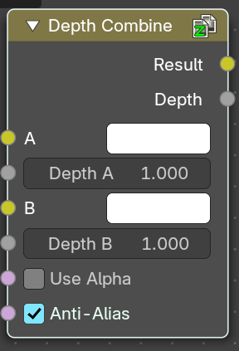
Depth Combine
The Depth Combine node combines two images based on their Z-depth maps. It overlays the images using the provided Z values to detect which parts of one image are in front of the other.

Inputs

A
The background image.

Depth A
Z depth of the background image.

B
The foreground image.

Depth B
Z depth of the foreground image.

Use Alpha
The chosen Image pixel alpha channel is also carried over. If a pixel is partially or totally transparent, the result of the Z Combine will also be partially transparent; in which case the background image will show through the foreground (chosen) pixel.

Anti-Alias Z
Applies Anti-Aliasing to avoid artifacts at sharp edges or areas with a high contrast.

Outputs

Result
If both Z values are equal, it will use the foreground image. Whichever Z value is less decides which image pixel is used. See Z-buffer.

Depth
The combined Z depth, which allows to thread multiple Z-combines together.

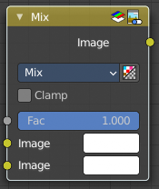
Mix Color
The Mix Node mixes images by working on the individual and corresponding pixels of the two input images. Called “MixRGB” in the shader and texture context.

Inputs

Factor
Controls the amount of influence the node exerts on the output image.

Image 1
Usually the background image. The image size and resolution sets the dimensions of the output image.

Image 2
Usually he foreground image.

Properties

Mix
Choose the different blending modes.
Add, Subtract, Multiply, Screen, Divide, Difference, Darken, Lighten, Overlay, Color Dodge, Color Burn, Hue, Saturation, Value, Color, Soft Light, Linear Light.

Clamp
Limit the highest color value to not exceed 1.

Outputs

Image
Image output.

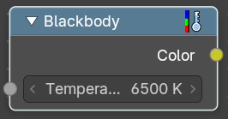
Blackbody
Convert a blackbody temperature to a rgb value.

Inputs

Temperature
The blackbody temperature.

Outputs

Color
The output RGB color.

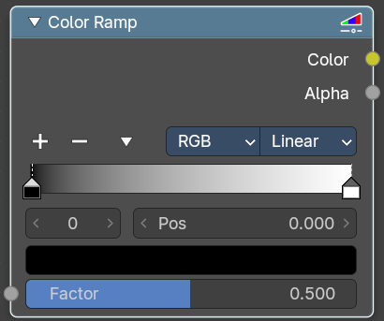
ColorRamp
The Color Ramp Node is used for mapping values to colors with the use of a gradient.

Inputs

Factor
The Factor input is used as an index for the color ramp.

Properties

Color Ramp
Color Ramps enables the user to specify a range of colors based on color stops. The color between the color stops gets interpolated.

Controls

+
Add a stop to your color ramp. The stop will be added after the selected one, in the middle to the next one.

-
Deletes the selected color stop from the list.


Tools menu

Flip Color Ramp
Flips the gradient, inverting the values of the color ramp.

Distribute Stops from Left
Rearrange the stops so that every step has the same space to the right.

Distribute Stops Evenly
Space between all neighboring stops becomes equal.

Eyedropper (pipette icon) E
An Eyedropper to sample a color or gradient from the interface to be used in the color ramp.

Reset Color Ramp

Resets the color ramp to its default state.

Color Mode

RGB
Blends color by mixing each color channel and combining.

HSV/HSL
Blends colors by first converting to HSV or HSL, mixing, then combining again. This has the advantage of maintaining saturation between different hues, where RGB would de-saturate, this allows for a richer gradient.


Interpolation

Ease
Uses an Ease Interpolation for the color stops.

Cardinal
Uses a Cardinal Interpolation for the color stops.

Linear
Uses a Linear Interpolation for the color stops.

B-Spline
Uses a B-Spline Interpolation for the color stops.

Constant
Uses a Constant Interpolation for the color stops.

Color Ramp
The color band. A click at one of the color stops makes it the active one. You can move the color stops by clicking at them and dragging them around.

Active Color Stop elements

Adjust the active color stop.

Choose active color stop
Choose the color stop by index.

Pos
The position of the active color stop. The range goes from 0.000 to 1.000

Outputs

Color
The color output.

Alpha
Alpha channel output.

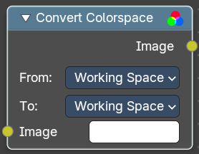
Convert Colorspace
Convert between color spaces.
Note that the conversion is skipped when converting between the same color spaces or to or from data spaces.

Input

Image
The input image.

Properties

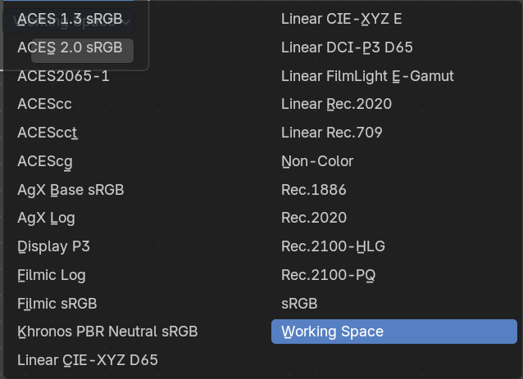
From
The current color space.

To
The destination color space.

Output

Image
The image output.

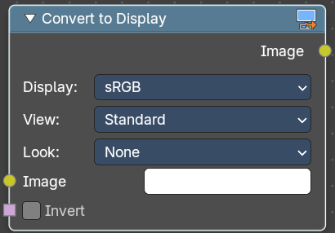
Convert to Display
Transforms an image from scene-linear color space into a display-referred format, using Blender’s color management pipeline. This is essential when working with raw data, custom view transforms, or prepping visuals for final output.

Inputs

Image
The input image in scene-linear space—typically the result of render layers, raw file input, or procedural compositing.

Invert
Reverses the display transform—useful for decoding display-referred images back to linear.

Properties

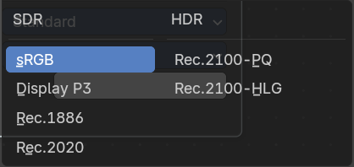
Display
Selects the target display device (e.g. sRGB, Rec.709, Display P3).
Determines how the image is mapped for viewing on screens.

View
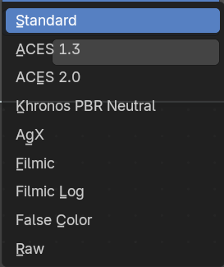
Applies a tone mapping curve (e.g. Standard, Filmic, Raw).
Controls contrast, highlight rolloff, and perceptual brightness.

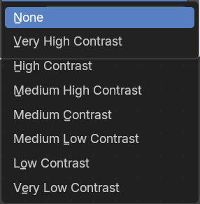

Look
Optional artistic adjustment layer (e.g. Medium Contrast, High Contrast, None).
Adds stylized tweaks on top of the view transform.

Output

Image
The display-referred result, ready for preview, export, or further compositing.

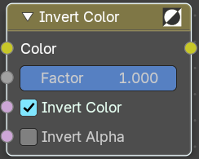
Invert Color
The Invert Node inverts the colors in the input image, producing a negative.

Inputs

Color
Standard input.

Factor
Controls the amount of influence the node exerts on the output image.

Invert Color
Invert the RGB values.

Invert Alpha
Invert the Alpha values.

Outputs

Color
Standard image output.
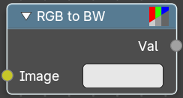

RGB to BW
The RGB to BW Node converts an RGB color image to a gray-scale image based at its luminance.

Inputs

Image
Color image input.

Outputs

Val
Gray-scale value output.

